The Ringwood Educational Foundation’s mission is to enhance and enrich the public school curriculum through mini-grants awarded to teachers in our four public schools.

Here are some of the projects and educational equipment that have been funded:

- New Computers and Chrome Books for Students
- New Smartboards for Classrooms
- Climbing Wall and Adjustable Basketball Hoops for Gymnasiums
- Musical Instruments, Art Supplies, and Science Kits
- Health/Nutrition, Science, and Reading programs for teachers

With continuing cutbacks in educational programs, your support for helping our Ringwood children becomes even more critical.

Thank you for your support!

The Ringwood Educational Foundation, Inc. has funded over $550,000 in grants to our public schools in the past twelve years. We can’t do it without YOUR support!

Register online:
https://runsignup.com/Race/NJ/Ringwood/ShepherdLake5K

Download race registration form:
http://www.ringwoodef.org/5k.html

Email inquiries:
shepherdlake5K@gmail.com

Rain or shine!

6:30 – Registration Begins
8:00 - 5K Run
9:30 - 1-Mile Timed Kids’ Race
Award Ceremony Immediately Following

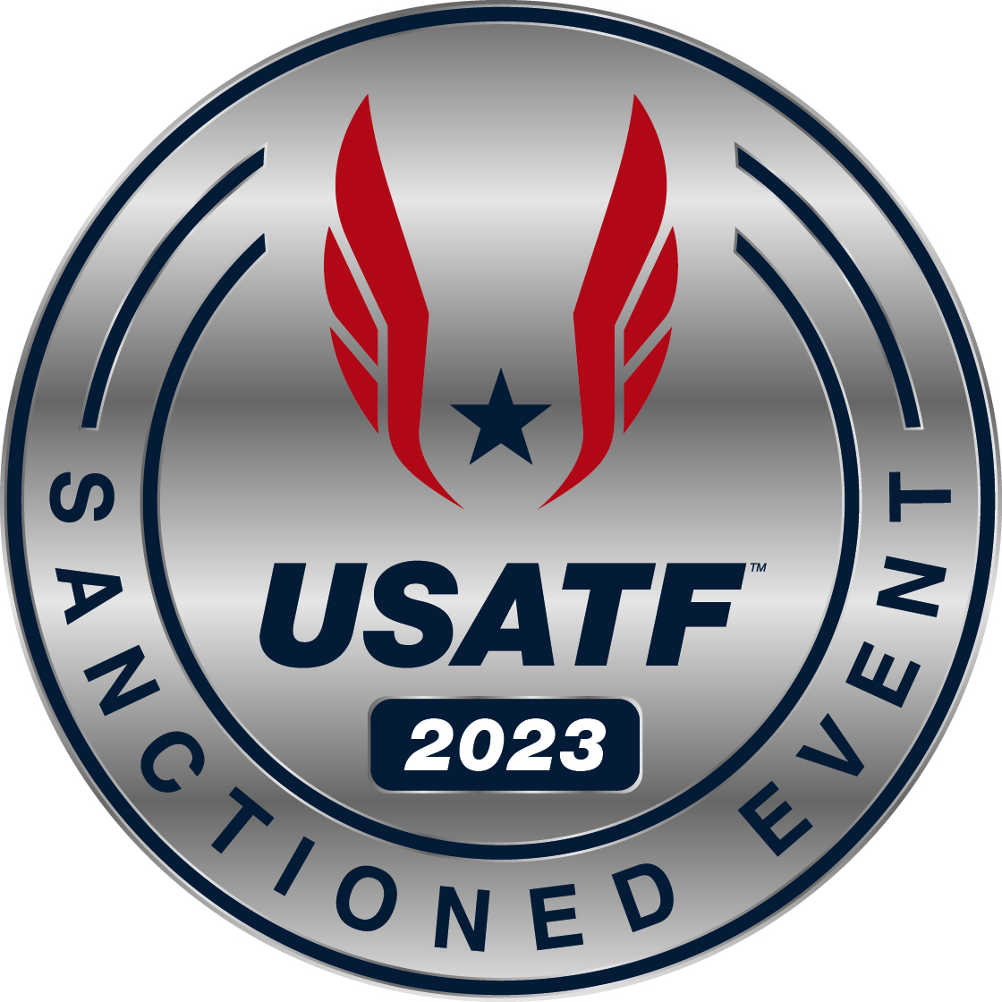

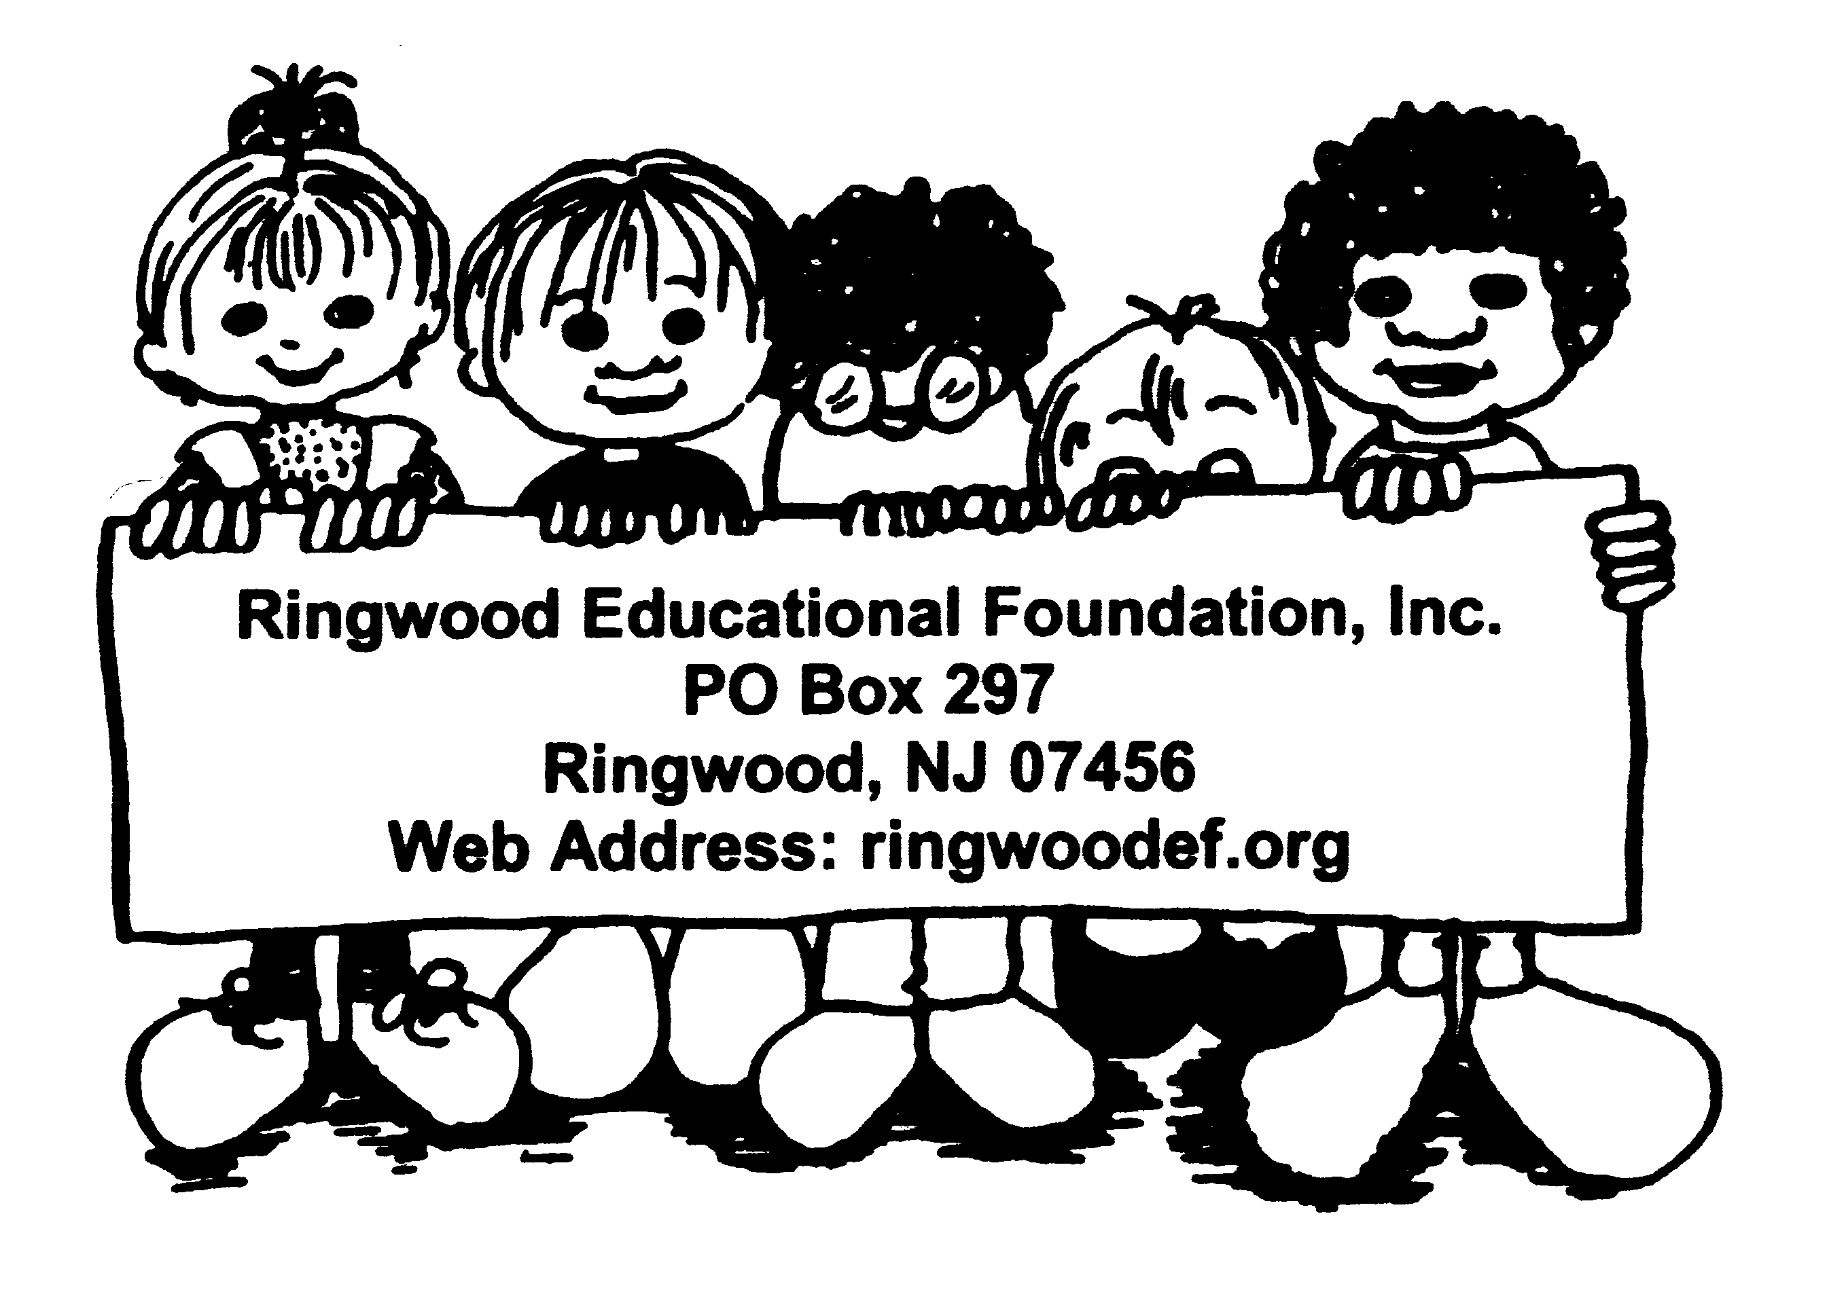
21st Annual
The Shepherd Lake 5K
Run/Walk
May 6th, 2023

Sponsored by
The Ringwood Educational Foundation

The Ringwood Educational Foundation Presents Our 21st Annual
SHEPHERD LAKE 5K
Saturday May 6th, 2023
Sponsorship Packages

The Ringwood Educational Foundation is proud to present our 21st annual 5K Run and Family Fitness Walk to be held at beautiful Shepherd Lake in Ringwood, NJ on May 6th, 2023. Once again we will feature our popular Kids’ Dashes as part of our fun-filled event!

Proceeds from the 5K Run benefit the Ringwood Educational Foundation, a not-for-profit organization dedicated to enhancing and enriching the curriculum in the Ringwood K-8 public school system.

This event is a growing attraction for athletes in and around the area, drawing participants from Northern New Jersey, New York’s Orange and Rockland Counties, as well as parts of Connecticut. In 2019, we had over 220 racers and more than 36 sponsors. In 2022, we had over 278 participants and over 20 sponsors.

We would like to offer you this opportunity to become an individual or corporate sponsor for this exciting event. Packages can be tailored to fit your unique corporate promotional needs. All contributions are fully tax deductible.

For additional information and registration visit our website at www.RingwoodEF.org, email inquiries to shepherdlake5K@gmail.com, or call Kasey (973) 495-6391

** Return form and check payable to “Ringwood Educational Foundation, Inc.” to:
REF, Inc., PO Box 297, Ringwood, NJ 07456.
Deadline: April 7th, 2023.

Gold Package: $500
- Name and logo prominently printed on back of race day T-Shirt.
- Banner displayed at start/finish line.
- Listing on REF website with link
- Booth Space

Silver Package: $250
- Name and logo on race-day T-shirt. This will be printed below gold sponsors.
- Listing on REF website.
- Booth Space

Bronze Package: $150
- Listing on REF, Inc. website

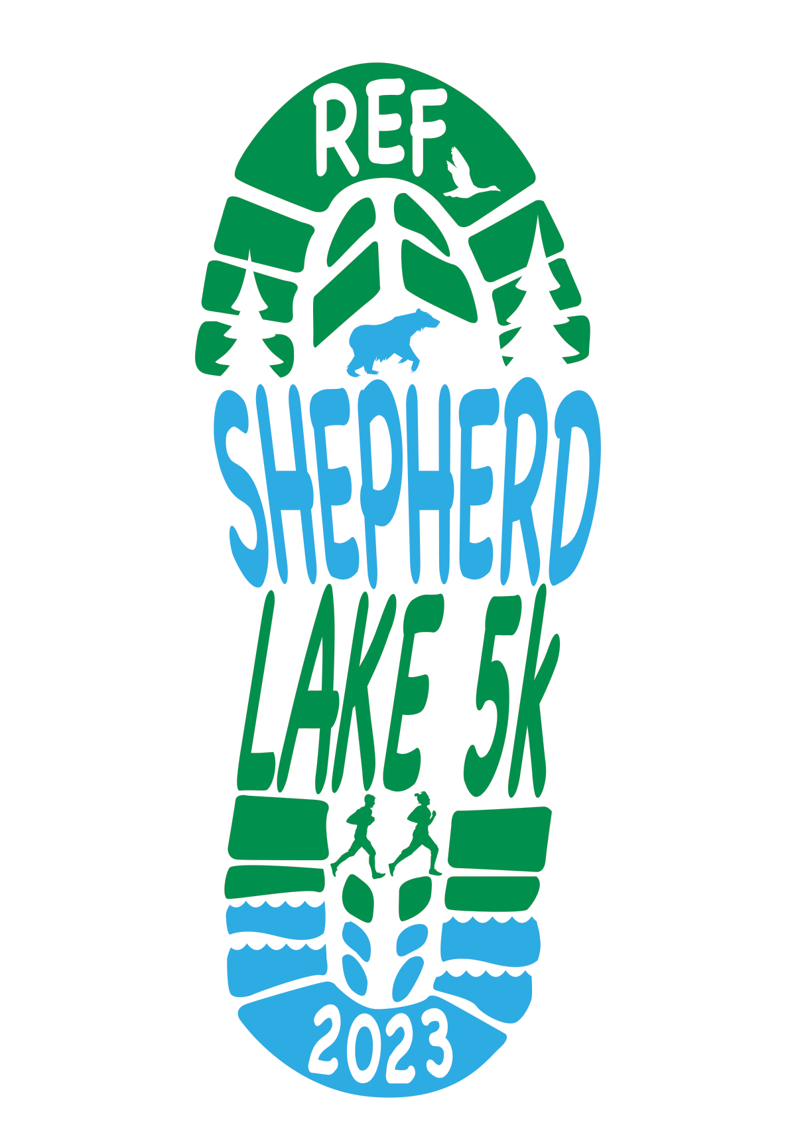
YES! WE WANT TO SPONSOR!

Sponsor Name______________________

Company__________________________

Address___________________________

City/State__________________________

Zip_______________________________

Phone_____________________________

E-mail_____________________________

Website____________________________

Sponsorship package:

Gold ($500) _____

Silver ($250) _____

Bronze ($150) _____

